Name_______________________________________

Introduction:
Recent research through the University of Akron is being done to help solve everyday problems in more inexpensive and efficient ways. Currently the spectrometer being used to analyze nitrogen and phosphate levels in water is expensive (typically around $3000). The cost of these spectrometers limits schools and other groups from owning and using the machines. It also limits the amount data being collected and close monitoring of local waterways for pollution and its’ sources. The research being done eliminates these problems by creating an affordable spectrometer that is portable and accurate. This spectrometer helps local schools and volunteer groups afford and help monitor local waterways for phosphate and nitrate levels. This further helps scientists have a collection of data that is accurate and reliable to then hopefully ensure any sources of pollution are either corrected or future problems in the ecosystem predicted before they happen. The spectrometer is made of simple material (polymer based plastics), mirror, prism, and an app added to a digital device. They can be constructed as a class project if the school has a FabLab. Today you will learn how to use these spectrometers to analyze local water samples for nitrate levels.
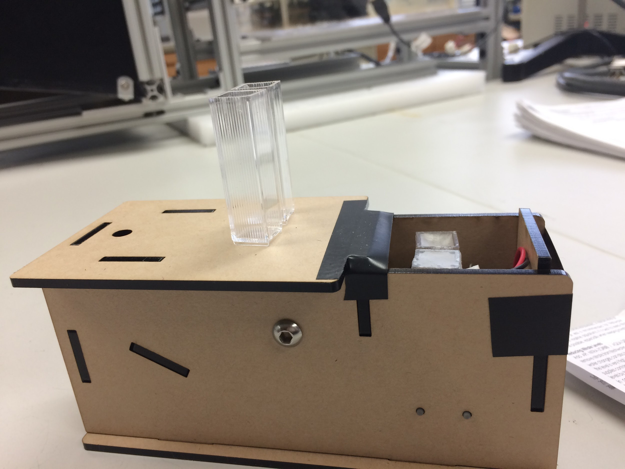

Materials:
- Spectrometer
- Water samples(students can bring from home)
- Nitrate reagent kit
- Pipettes
- Computer
- App for phone
- Gloves
- Goggles
- 3 prepared samples/ one or two positive for nitrate (need to buy nitrate solution to add to samples to create positive samples)

Activity:

Instructions on how to prepare samples:

Sample 1 (control)

- Add 2 mL of water sample to container 1 and cap

Sample 2 (water and reagent)

- Add 2 mL of water sample to container 2
- Add 2 drops of Nitrate Test Solution (#1 marked bottle) to container
- Cap and invert (shake) container for 30 sec
- Pick up Nitrate Test Solution (#2) and vigorously shake the bottle for 10 sec
- Add to container 2- 2 drops of Nitrate Test Solution (#2)
- Cap container 2 and shake vigorously for 1 minute ******very important step/if done incorrectly then results may not be accurate
- Put sample down and wait 5 minutes for color to develop
- Use color strip to read results.
- Document results in data table below.
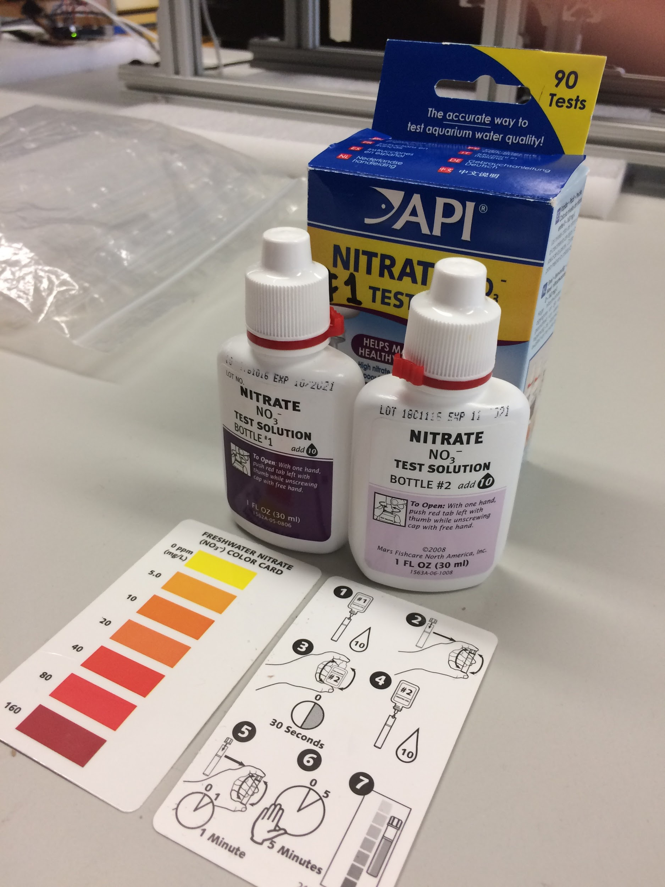
*******Only do this section if you have a spectrometer and app on phone available. If not modify lab instruction sheet to include API solution only.

Instructions on how to use spectrometer:
- Turn spectrometer on by switching button to on position on the bottom of the machine.
- Take control sample(previously made sample 1) and pour into container one for spectrometer and place cap on top. Place control in position one of spectrometer.
- Take sample with reagent (sample 2) and pour into container 2 of spectrometer and place cap on top. Place into position 2 of spectrometer.
- Turn phone on and open OES application.
- Place lens of camera over opening where the prism is present. You will see the prism on your phone screen. If you do not keep moving phone until you see the image. Make sure that the camera lens is over the hole in the spectrometer. (labeled 3)
- You should see two distinct rainbows on your camera or you have not placed your phone correctly. Refer to diagram below.
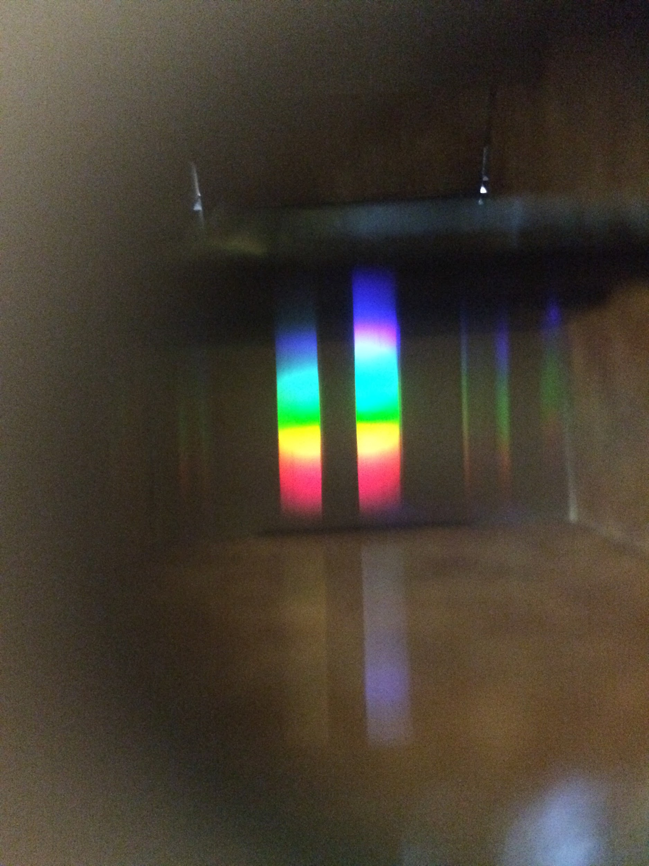
- Take a picture/save picture if needed/close camera
- Hit analyze my image/push nitrate
- Document results in data table below.
Take measurements from samples 1, 2, and 3 and document in the data table below:
Data Table 1
Sample Number | Color Chart results (mg/L) | Spectrometer results (mg/L)
Sample 1
Sample 2
Sample 3

You receive 3 samples from a citizen science group. The samples come from three rivers that contribute to a lake that now is showing signs of eutrophication. They believe that one of the rivers may be contributing to the high nitrate levels in the lake. Test all three samples and document your results in the data table below. Test for nitrate in the water samples using both the API color chart and the spectrometer.

Data Table 2
 | Positive | Negative
Sample1
Sample 2
Sample 3
Analysis of Data:

- In data table 1, which samples were positive? Where were these samples taken?

2. Do the results from the color chart differ from the results of the field spectrometer? If so how?

3. Which set of results was more accurate (Field spectrometer or color chart)?

4. Is the color chart easy to read or determine the correct color?

5. In data table 2 which samples were positive? Which were negative? Can you locate the source of pollution using these machines?

Discussion:

Observe the sites below in the pictures and notice their descriptions.

Sample 1 site (upstream) Sample 2 site Sample 3 site (downstream)
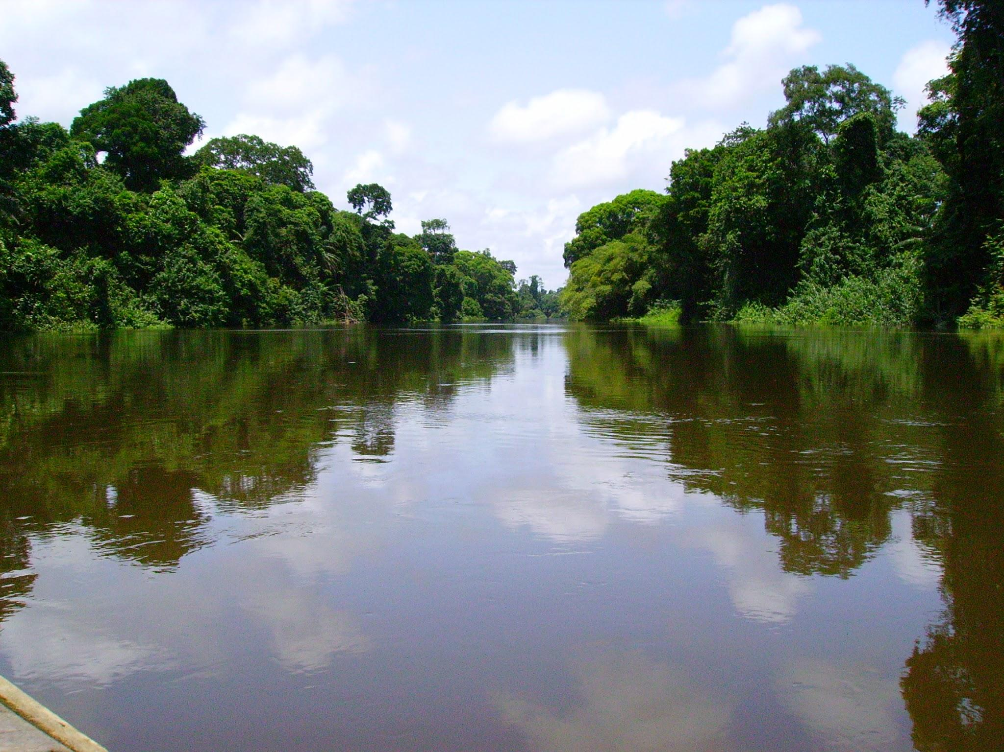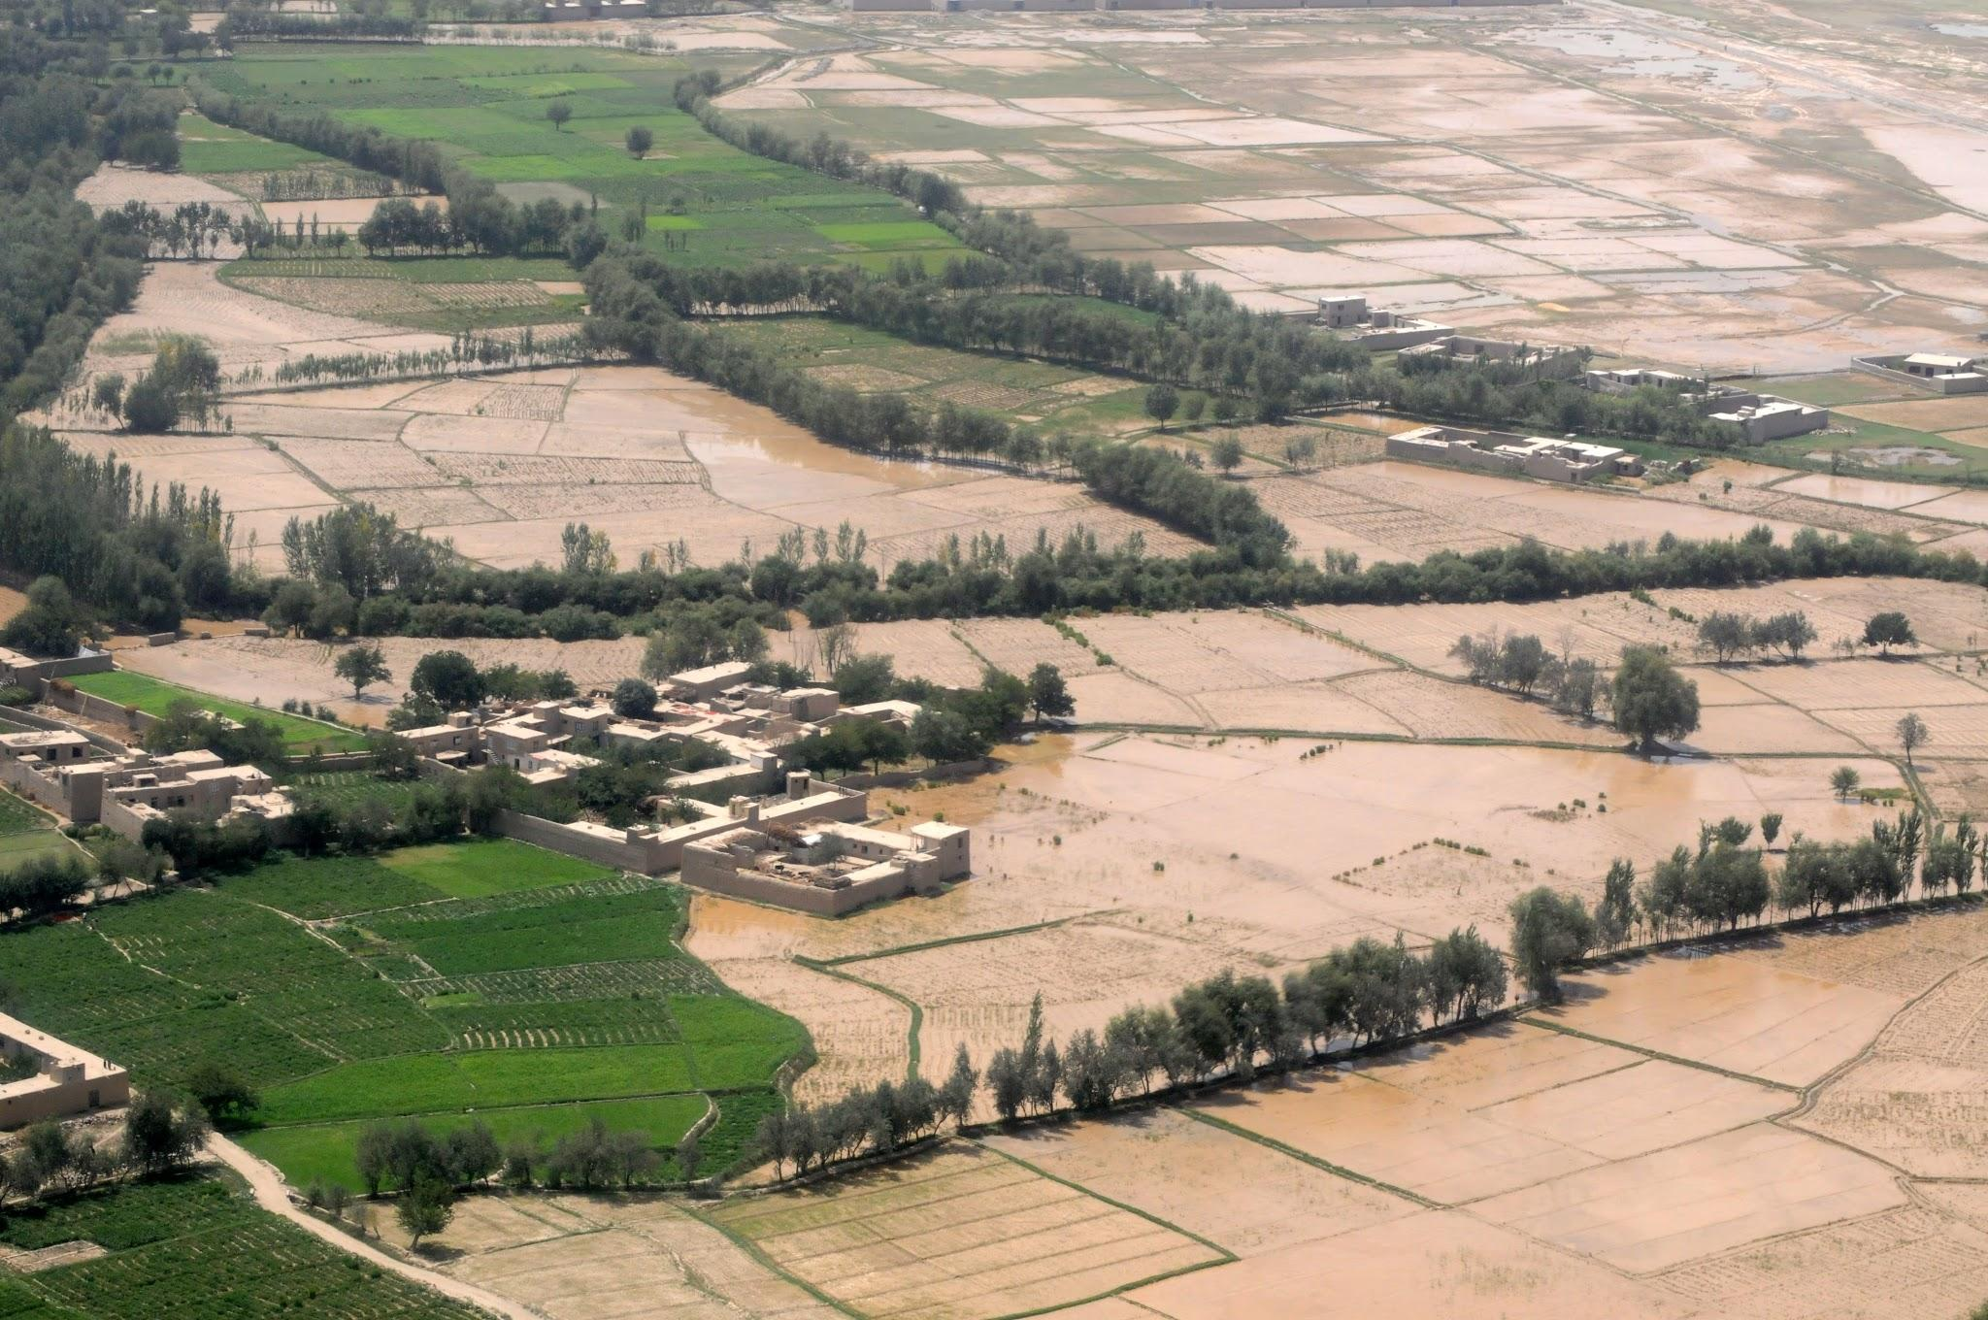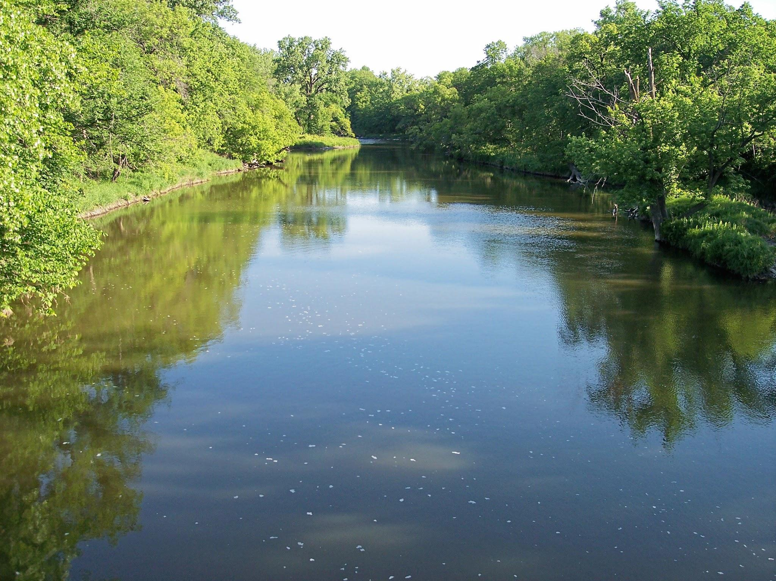

Describe Site 1:
Describe Site 2:
Describe Site 3:

1. Which sites do you think nitrate levels may be higher? Why do you think they would be higher at those locations?

2. Would this spectrometer be helpful in helping in monitoring these location for possible pollution leaks?

3. What are some solutions that can be done if it is found that there are higher than normal levels of nitrate in these areas?

Name_________________________________________

Extension questions on field spectrometer.

Polymers are large molecules made from monomers. There are several examples of uses of polymers in everyday life. Plastic and styrofoam are examples of polymers that are useful and used to make a large quantity of products we find in everyday life. Biological polymers include DNA, carbohydrates, proteins, and lipids. We will discuss this year in great detail how important these polymers are to all living things. They are the building blocks of life. Cellulose is a biological polymer (carbohydrate) made from plants. While some polymers are synthetic such as those we use to make many plastics, others come from living things that we use to build useful products. With a large amount of people on this planet that do not have access to clean water, we are using polymers to create filters that help remove toxins from water and make it drinkable. Read the following article on filters that help clean water and answer the following questions:

https://www.nap.edu/read/18734/chapter/7

- How many people and what percent of the population is without clean drinking water?

2. What type of risks do these people take when they drink water and how many deaths result from those risks?

3. How much of the water on this planet is salty and how much is fresh?

4. What are some of the threats to the water supply in the United States?

5. Read the remainder of the article and with 5-6 sentences describe what scientists are doing with polymers/filters to help solve global non-drinkable water problems.

